3D Port AGV Path Planning Project Outline
Team members Member 1 | Member 2 | Member 3 | Member 4

1 Realistic port scenario and research question
We will develop a 3D maritime terminal simulation to compare fleet path planning under container workloads, congestion and disruptions. The research question is whether rolling horizon coordination with footprint reservations improves completed moves and delay over shortest routes with fixed priorities as the fleet grows from 20–30 to 500 AGVs.
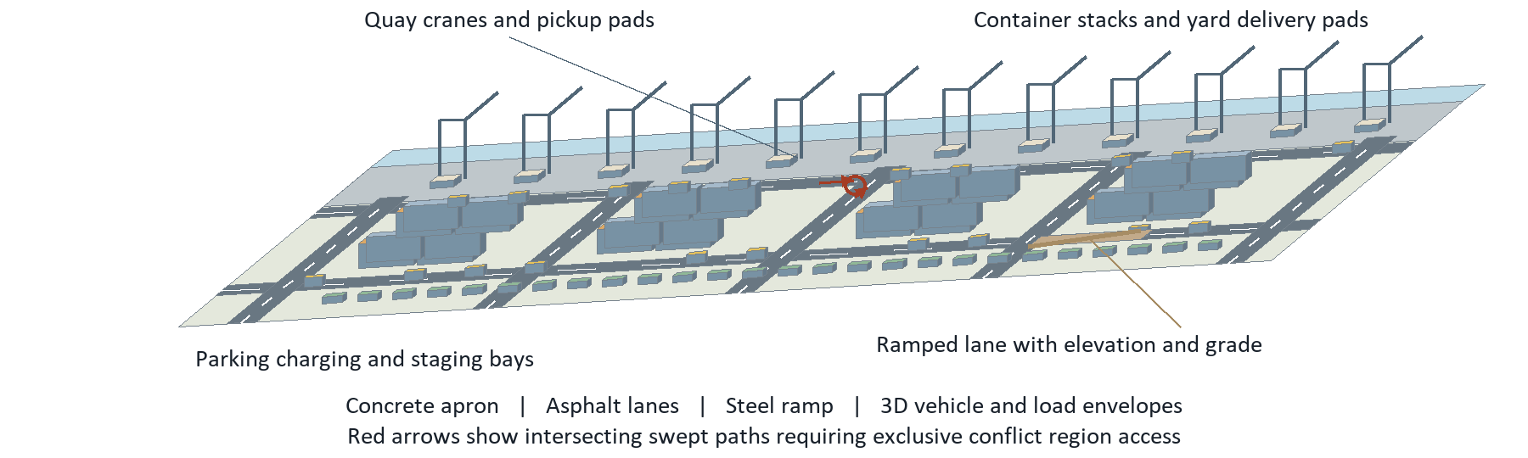
Figure 1. Original proposed 3D terminal schematic, not to scale. Red trajectories conflict at a junction. Lanes and pads have continuous physical dimensions, elevations and clearances.
Port model. Begin with a configurable 1,500 × 800 m terminal, 12 quay cranes, 16 storage blocks, transfer queues, chargers and 600 staging or parking bays. These are proposed synthetic dimensions and capacities pending site data. Import surveyed geometry when available. A directed lane graph supports routing; the authoritative world uses continuous 3D geometry, lane widths, turning areas, docking pads, stack heights and overhead clearance.
Materials and terrain. Tag concrete apron, asphalt roads, paved service areas, steel ramps and nondrivable gravel. Store friction in dry and wet conditions, rolling resistance and traversability separately from visual texture. Model elevation, longitudinal grade and cross slope; start with 0–4 m elevation variation and selected 0–3% ramps as test assumptions. Grade and surface properties affect speed, energy and loaded braking.
Fleet and movement. Test 20 and 30 AGVs first, then 50, 100, 200, 300 and 500. For 20 vehicles, use 8 quay, 8 yard and 4 parking staging bays; for 30, use 12, 12 and 6. Seed larger fleets into validated nonoverlapping bays. Select one nonarticulated vehicle family, modeling its actual steering, full vehicle/load envelope, turning radius, acceleration, braking and loaded/empty limits. Stop and reverse only where physically feasible and permitted.
Tasks and scope. Assign repeated pickup–delivery jobs through the same dispatcher for both pathing methods. Crane service, queues, load custody and charging consume real resources. Required scope includes 3D inspection, continuous motion, conflict monitoring and headless experiments. Sensors and learning are later additions. Validate shared junction access, opposing lane travel, turning clearance and blocked exits [1, sections 1–10].

2 PettingZoo environment and simulation contracts
PettingZoo Parallel supplies simultaneous AGV decisions over one simulation kernel [2]. The kernel advances physical truth, cranes, jobs and energy independently of the 3D viewer. The planner proposes trajectories and reservations; the environment enforces vehicle constraints and resource ownership.
Figure 2. Joint decisions feed the physical simulation and independent monitors; logs support live 3D inspection and replay. Original workflow.
Agents and observations. Use stable agv_000 through agv_499 identifiers with a fixed possible_agents list per configured environment. Local observations include 3D pose, speed, heading, load, battery, task, neighboring footprints, lane grade/material, reservation state and observation age. Global state exposes all current vehicles, resource queues and the semantic yard to both centralized planners. Future demand and faults remain hidden; masks handle variable neighbors.
Actions and timing. Each AGV proposes a legal route segment with a bounded speed profile, hold or controlled stop. Docking and reversing require permitted modes. Replan initially every 1 simulated second while motion integrates at 20 Hz, with event driven service/fault transitions and finer collision checks. Use integer timestamps, stable ordering and seeded random streams. Declare virtual planner time for algorithm studies; separately inject compute/communication delay for deployment timing tests [1, section 7].
Joint transitions. Validate timestamped actions together, then atomically commit feasible reservations over swept vehicle/load footprints. Detect crossing paths, opposing travel, following distance and braking violations throughout each interval. Retain occupied resources until physically cleared. Reject invalid or stale proposals with reasons; continue a still valid trajectory or execute a feasible controlled stop. An independent monitor logs unsafe proposals, interventions and actual contacts. Reward penalties never substitute for collision handling.
Rewards and boundaries. Proposed reward is +10 per completed move, −0.01 per simulated second of unfinished task delay, −0.1 per kWh and −1 per unsafe proposal; report each component and all operational KPIs separately. Use an 8 hour shift plus at most 1 hour of drain time. Terminate successfully after released jobs finish and vehicles park; terminate on an unrecoverable simulation invariant failure. Truncate unfinished work at the 9 hour limit, preserving backlog. Ordinary planner delays and recoverable faults remain measurable outcomes.
Interface and 3D view. reset(seed, options) loads versioned yard, vehicle and workload packages and returns observations/infos. step(actions) advances one decision interval and returns dictionaries for observations, rewards, terminations, truncations and infos. Maintain physically present AGVs until the run ends. render() shows terrain, material layers, stacks, cranes, moving loads and route/braking/reservation overlays; camera selection explains blockers. close() releases resources. Save events, trajectories, seeds and checkpoints for reproducible replay [1, 2].

3 Pathing comparisons experiments and delivery
Baseline. Travel time weighted shortest routes use the lane graph and common dispatcher. Fixed priority manages intersections; footprint aware following and physically feasible stops govern execution. Reroute on closure. The baseline and comparison use the same vehicle controller, world model, observations and safety checks.
Comparison. Rolling horizon prioritized space–time search reserves swept footprints, transfer pads and holding areas with priority aging. Begin with a 20 second lookahead and commit 1 second; tune against stopping distance and bottlenecks. Use vehicle feasible motion primitives, downstream space checks and atomic repair. On timeout, preserve a valid continuation or stop feasibly. Evaluate SIPP adaptations or LNS after the pipeline works [1, sections 8–10].
Experiments. Sweep 20, 30, 50, 100, 200, 300 and 500 active vehicles. Independently vary demand, bursts, bottlenecks, wet friction, gradients, crane outage, stalled vehicle and command delay. Keep terminal capacity fixed in the primary scaling study so saturation remains visible. A separate larger yard tests transferability. Pair methods on identical manifests and faults; begin with 20 seeds, equal compute budgets and matched information. Report intervals and all unfinished work [1, section 16].
Metrics and deadlocks. Measure completed moves, success rate, task completion time, loaded/empty distance, waiting, collisions, minimum clearance, near misses, deadlocks, recovery, timeouts and energy per move. Also measure p95/p99 planning latency, deadline misses, simulation speed, memory and viewer frame rate. Flag 60 seconds without physical or service progress; confirm a persistent wait cycle only after excluding scheduled releases and finding no feasible escape.
Correctness gates. Check shared pads, opposing travel, blocked routes and parked AGVs, plus turning envelopes, between tick contacts, loaded braking on wet grades, load conservation and snapshot replay. Run parallel_api_test and parallel_seed_test. Require collision evidence and scale profiling at each fleet tier; 500 vehicles is a stress target, not an established real time capability [1, section 17; 3].
Stage | Lead | Milestone and reviewable output
1 | Member 1 | Yard materials/terrain, vehicle data and 20–30 AGV kernel.
2 | Member 2 | Baseline, service semantics and physical correctness suite.
3 | Member 3 | Reservation planner, recovery and 50–300 AGV profiling.
4 | Member 4 | 3D replay, paired experiments and 500 AGV stress reports.
Delivery risks. Freeze scope through measured gates, not a four week promise. Missing site data requires labeled synthetic parameters. Bound search and telemetry, use spatial indexes and instanced rendering. If capacity is limited, retain realistic 3D and 20–30 vehicles while deferring sensors/RL; continue headless 500 vehicle stress tests and report measured limits.
Sources. [1] Autonomous port yard vehicle simulator, 16 September 2026, sections 1–13, 16–21. [2] Farama Foundation, pettingzoo.farama.org/api/parallel/. [3] Farama Foundation, pettingzoo.farama.org/content/environment_tests/. Accessed 14 October 2026.

